***Salesforce Property Management App***

***By Marthand Bhargav***

# Phase 2: Org Setup & Configuration

This phase focused on establishing the foundational settings and user structure within the Salesforce Developer Edition org to support the PropertyHub application.

## Company Profile Setup

Set basic org details under *Setup → Company Information → Edit*:

* **Name**: Property Management Solutions
* **Time Zone**: (GMT-07:00) Pacific Daylight Time (America/Los_Angeles)
* **Locale**: English (US)
* **Language**: English
* **Currency**: English (United States) - USD

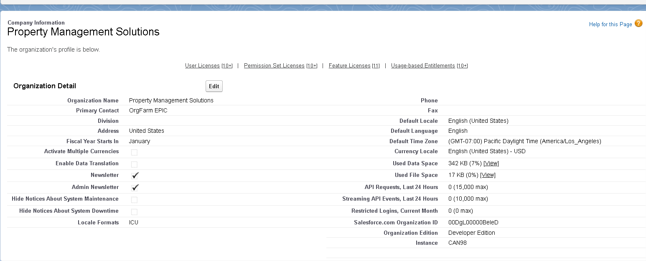

## Business Hours Setup

Configure working hours for escalation rules and SLA tracking:

* **Path**: *Setup → Business Hours → New*.
* **Name**: Standard Property Management Solutions Business Hours

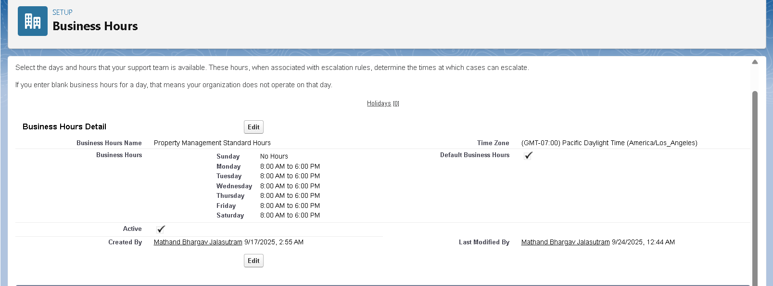

## Fiscal Year Setup

Defines reporting boundaries for forecasts and opportunities.

* **Path:** *Setup → Fiscal Year.*
* **Type:** Standard Fiscal Year (Jan–Dec)
* **Configuration:** Starting month set to *January*.

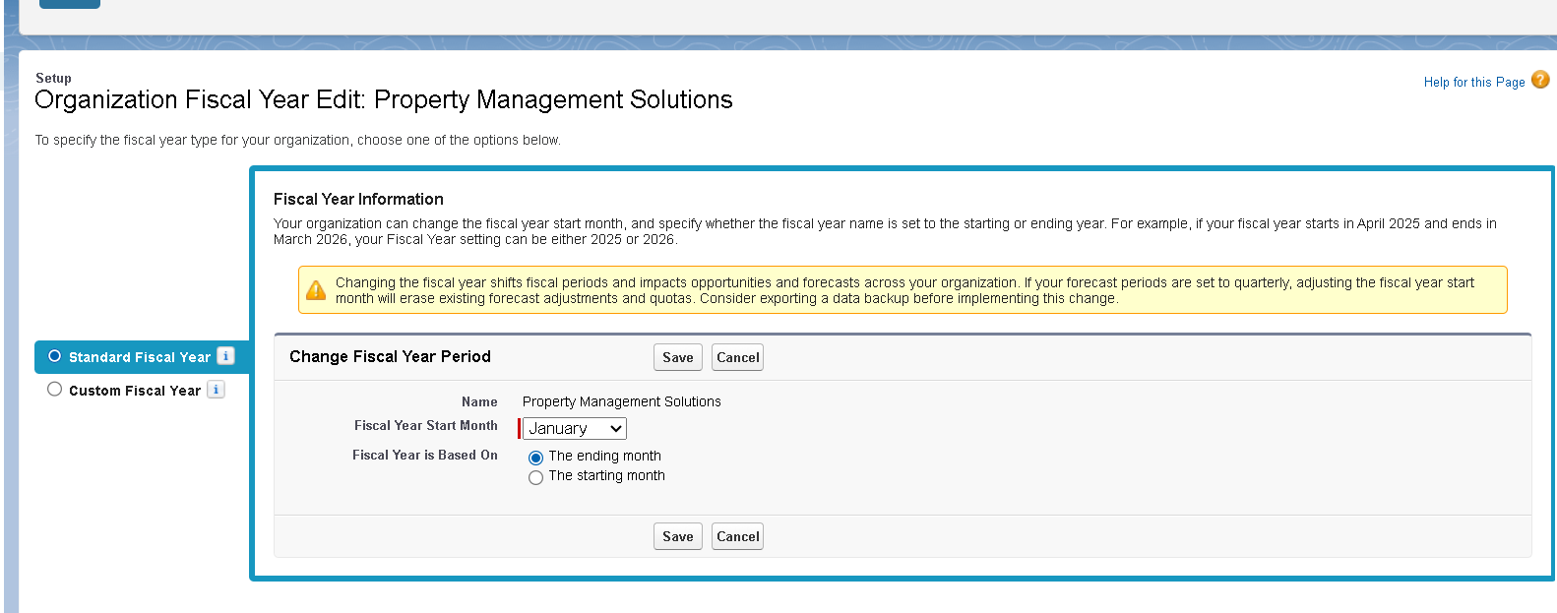

**4. User Management Architecture**

***Create Roles Step by Step:***

1. *CEO Role:* 
   * *Click "Add Role"*
   * *Role Name: CEO*
   * *This role reports to: --None--*
   * *Contact & Opportunity Access: Controlled by Parent*
   * *Case Access: Controlled by Parent*
2. *Regional Manager:* 
   * *Role Name: Regional Manager*
   * *This role reports to: CEO*
   * *Contact & Opportunity Access: Controlled by Parent*
3. *Property Manager:* 
   * *Role Name: Property Manager*
   * *This role reports to: Regional Manager*
   * *Contact & Opportunity Access: Controlled by Parent*
4. *Maintenance Supervisor:* 
   * *Role Name: Maintenance Supervisor*
   * *This role reports to: Regional Manager*
5. *Maintenance Staff:* 
   * *Role Name: Maintenance Staff*
   * *This role reports to: Maintenance Supervisor*
6. *Finance Manager:* 
   * *Role Name: Finance Manager*
   * *This role reports to: CEO*

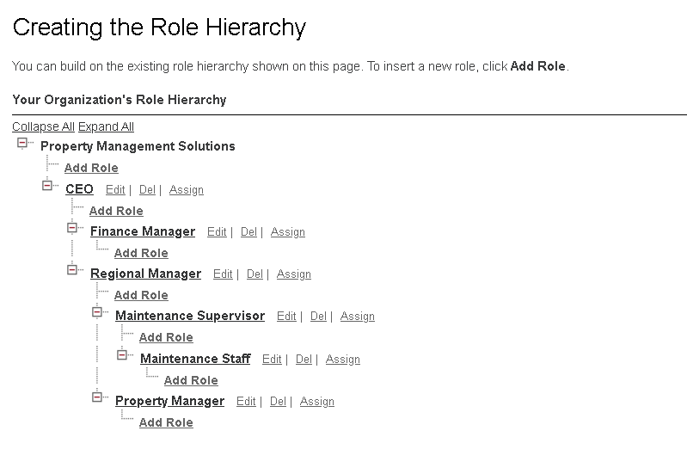

## OWD (Org Wide Default)

This has to be done in Phase 3, as the OWD settings are needed to be applied on custom objects which will be implemented in the next phase of the project.

**Permission Sets.**

* Create Specialized Permission Sets

## Path: Setup → Users → Permission Sets

## Property Analytics Permission Set:

## Click "New"

## Label: Property Analytics Access

## API Name: Property_Analytics_Access

## Description: Advanced reporting and dashboard access for property analytics

## License: Salesforce

## Save

## Configure Permissions:

## App Permissions:

## Analytics Cloud: ✓ (if available)

## Reports and Dashboards: ✓

## System Permissions:

## Create and Customize Reports: ✓

## Create and Customize Dashboards: ✓

## Manage Dynamic Dashboards: ✓

## Run Reports: ✓

## Emergency Maintenance Permission Set:

## Label: Emergency Maintenance Access

## API Name: Emergency_Maintenance_Access

## Description: After-hours access for emergency maintenance

## System Permissions:

## View Setup and Configuration: ✓

## Manage Maintenance Requests: Custom permission (to be created)

## B. Assign Permission Sets

## Path: Setup → Users → Users → [Select User] → Permission Set Assignments

## Select "Property Manager" user

## Click "Edit Assignments"

## Add "Property Analytics Access"

## Save

## Step 9: Organization-Wide Defaults (OWD)

## A. Configure Sharing Settings

## Path: Setup → Security → Sharing Settings

## Set OWD for Custom Objects:

## Property__c:

## Default Internal Access: Public Read/Write

## Default External Access: Private (if communities enabled)

## Grant Access Using Hierarchies: ✓

## Tenant__c:

## Default Internal Access: Private

## Default External Access: Private

## Grant Access Using Hierarchies: ✓

## Reason: Sensitive PII information

## Lease__c:

## Default Internal Access: Public Read Only

## Default External Access: Private

## Grant Access Using Hierarchies: ✓

## Payment__c:

## Default Internal Access: Private

## Default External Access: Private

## Grant Access Using Hierarchies: ✓

## Reason: Financial information

## Maintenance_Request__c:

## Default Internal Access: Public Read/Write

## Default External Access: Private

## Grant Access Using Hierarchies: ✓

## Dev Org Setup

* To implement this project, a Salesforce Developer Edition org was set up.
* A GitHub Repository was created for source control.
* VS Code and SFDX were set up for the implementation of the LWC components for development.

## Next Steps: Phase 3

With the organizational foundation complete, development will begin on the core functionality:

* Custom Object Creation (Property, Visit, Offer)
* Automation via Flows and Apex Triggers
* Configuring OWD and Sharing Rules for objects

Building the Lightning App and custom Lightning Web Components